Date: 24/09/2024
Roll No. and Name: 24ITC087 Khush Pithva
Course Code and Name: 2CS101 Computer Programming
Practical No: 5(a)(i)
Aim:Build a program (i).To reverse all elements of original array
Methodology Followed:

#include <stdio.h>

int main()
{
int n;

printf("Enter the number of elements in the array: ");
scanf("%d", &n);

int array[n];

printf("Enter %d elements: \n", n);
for(int i = 0; i < n; i++)
{
scanf("%d", &array[i]);
}

for(int i = 0; i < n / 2; i++)
{
int temp,s=n - i - 1;
temp = array[i];
array[i] = array[s];
array[s] = temp;
}

printf("Reversed array: \n");
for(int i = 0; i < n; i++)
{
printf("%d ", array[i]);
}

return 0;
}

Input/Output:
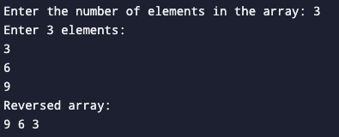

Theoretical Principle: For the first time an array was made by asking input from the user.

Practical No: 5(a)(ii)
Aim: To find out maximum element of an original array and print its location.
Methodology Followed:

#include<stdio.h>
int main()
{
int n;
printf("Enter size of array : ");
scanf("%d",&n);
int x[n];
printf("\nEnter element below \n");
for(int i=0;i<n;i++)
{
scanf("%d",&x[i]);
}
int big=x[0],index=0;
for(int i=1;i<n;i++)
{
if(x[i]>big)
{
big=x[i];
index=i;
}
}
printf("\nBiggest elemnet is %d \n",big);
printf("and the index is %d",index);
}

Input/Output:
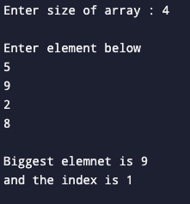
Theoretical Principle: We use 1D for the first time and also print the location by using the index by the user.

Practical No: 5(b)
Aim: Suppose that a class has 5 students.Each student studies for subjects; CP, CS,Maths, and Physics.Make a 2d Array for the same. Build a C program.(i) To find total marks in all subjects obtained by each student. (ii) To find average marks obtained by all 5 students in a C programming subject.
Methodology Followed:
#include <stdio.h>
//done
int main()
{
int std[100][7],i,x;
printf("\n Enter number of student: ");
scanf("%d",&x);
for(i=0;i<x;i++)
{
printf("\n Enter seat number : ");
scanf("%d",&std[i][0]);
printf("\n Enter mark of CP : ");
scanf("%d",&std[i][1]);
printf("\n Enter mark of CS : ");
scanf("%d",&std[i][2]);
printf("\n Enter mark of Maths : ");
scanf("%d",&std[i][3]);
printf("\n Enter mark of Physics : ");
scanf("%d",&std[i][4]);
std[i][5]=std[i][1]+std[i][2]+std[i][3]+std[i][4];
std[i][6]=std[i][5]/4;
printf("\n Total : %d",std[i][4]);
printf("\n avrage : %d",std[i][5]);
}
printf("\n\tseat no\t\tCP \tCS \tMaths\tPhysics\t\tTotal\tAvrage");
for(i=0;i<x;i++)
printf("\n\t%d\t\t\t%d\t\t%d\t\t %d\t\t%d\t\t%d\t\t%d",std[i][0],std[i][1],std[i][2],std[i][3],std[i][4],std[i][5],std[i][6]);
}

Input/Output:
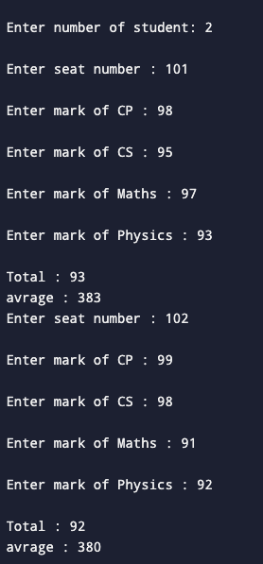
Theoretical Principle: Using 2D array for the first time we store the marks for the students for 4 different subjects and then find the total marks in all subjects by each student and average the marks.
Conclusion: We learn arrays of different types and perform different operations on it.

